

**Department of Creative Industries and Digital Technologies**

**Te Hoe Hōkai Pakihi**

**CH3866 Bachelor of Information and Communication Technologies**

**CH3880 Graduate Diploma in Information and Communication Technologies**

**BCIS309 Work Integrated Learning Project**

**Semester 2, 2023**

**SEO IMPROVEMENTS AND API DEVELOPMENT FOR WELLNOW**

**FINAL REPORT**

BROCK WINTER

99169332

Contents

Executive Summary 1

Halfway Report Executive Summary 1

Final Report Executive Summary 2

Introduction 3

Project Details 4

Project Name 4

Overview of Industry Client 4

Project Background 5

Project Scope 6

Project Goal(s) 6

Benefits of Project 6

Project Requirements 7

Expected Deliverables 7

Halfway Reports 8

Final Report 10

Stakeholder Management 14

Project Hierarchy 14

Reporting and Meetings 15

Student Skills 21

General Skills Required 21

ICT Specific Skills Required 21

Skills from Relevant L6 and L7 Courses 21

Approach to Learning New Skills 23

Project Plan – High Level 25

Phases 25

Development Lifecycle 28

Sprint One Necessary Research 28

Sprint Two and Three SEO Improvements Services Pages 28

Sprint Four SEO Improvements Practices Pages 28

Sprint Five Nookal and Setmore API Integration 28

Sprint Six 28

Timetable 29

Burndown Charts 31

Resources/Access Required 32

Detailed Project Plan 33

Reflection 33

Risk Management 34

Approach 34

Risk Table 34

Halfway Update 37

Final Update 37

Quality Assurance 38

Approach 38

Quality Assurance Table 39

Notes about Quality Assurance Tasks 39

Test Plan/Scenarios/Cases 40

Methodology 41

Essay Summary 41

Professionalism 42

Professional Standards 42

Relevance of ITP Code of Ethics 43

Relevant Legislation 44

Reflection 45

Sustainability, Inclusive Practice and Te Tiriti o Waitangi 46

Relevance of Principles to Student and Industry 46

Self-Assessments 48

Halfway Self-Assessment 48

Self-Assessments 49

Final Self-Assessment 49

Reflections 50

Approach 50

Final Summary 50

References 52

Appendices 53

Document Control

|  |  |  |  |
| --- | --- | --- | --- |
| Date | Author | Version | Status of Document/Updates Made |
| 22/08/2023 | Brock Winter | v0.1 | Document Creation |
| 04/09/2023 | Brock Winter | v0.2 | Submitted for feedback |
| 07/09/2023 | Brock Winter | v1.0 | Signed Off |
| 18/09/2023 | Brock Winter | v1.1 | Document Update |
| 12/10/2023 | Brock Winter | V2 | Halfway Report |
| 29/11/2023 | Brock Winter | V3 | Final Report |

# Executive Summary

## Halfway Report Executive Summary

Academic

There is a large number of academic tasks that have been completed such as a cv, reports, profile summary, poster etc.

Academic and Industry data will be securely kept in multiple places to ensure its safety.

These tasks once completed are reviewed to ensure high quality. Weekly meetings are also held to ensure the project stays on track.

So far, a large number of hours have been spent doing academic work and I predict it will be more likely 180 academic hours instead of 150.

Industry

This project is about creating content pages for WellNows website to increase the search engine ranking and add additional APIs.

This will increase the number of views the site gets and enable more practitioners and clinics to join.

To complete this I will be using the skills I have learned through a variety of different developer and project management classes.

There are two sets of pages for the SEO Improvements. The first is for the services offered such as physiotherapy, osteopathy, and chiropractic. The second is for Practices which will link the clinics and their practitioners.

The APIs that will be developed are for Nookal and Setmore. There was a third called Acuity but due to their API key being restricted to an upgraded plan it is no longer viable.

Multiple risks such as data exposure have been identified and steps have been taken to mitigate the chances of it occurring and its impact.

Throughout the development there are multiple steps taken to ensure that quality is upheld, such as design reviews, code reviews, automated testing, and user acceptance tests.

To improve the chance of success I will be using Agile, Scrum, and Kanban methodologies. These will help with ensuring the project is on track and proper communication is had.

Along the way during development there have been a few delays such as, not having all the information for the API key authentication and an increased focus on academic work. But now all that has been figured out and work should continue smoothly.

Currently this project is behind schedule but with no blockers work should proceed rather smoothly and it will be completed on time.

## Final Report Executive Summary

There is a large number of academic tasks that have been completed such as a cv, reports, profile summary, poster, poster short paper, panel presentation, elevator pitch, and the methodology essay. The time spent on these tasks have been recorded and tracked.

Academic and Industry data will be securely kept in multiple places to ensure its safety.

These tasks once completed are reviewed to ensure high quality. Weekly meetings are also held to ensure the project stays on track.

So far, 300 industry hours and roughly 200 academic hours have been achieved bringing the total to around 500 hours.

This project is about creating content pages for WellNow’s website to increase amount of content on the website. Which will help the search engine ranking and increase traffic to the site. There was also an initial mock-up of code created for the APIs. The APIs once completed will help enable more practitioners to join.

To complete this I will be used the skills I have learned through a variety of different developer and project management classes. I also acquired new skills and mention how I acquired them.

There are two sets of pages for the SEO Improvements. The first is for the services offered such as physiotherapy, osteopathy, and chiropractic, etc. The second is for Practices which will display a list of clinics and from there they can select a clinic and have the site display information about the clinic and the practitioners who work there.

Necessary research has been conducted for Nookal, Setmore and Acuity. I investigated how their appointment booking software worked. Afterwards I created initial mock-ups of code.

Multiple risks such as data exposure have been identified and steps were taken to mitigate the chances of it occurring. Steps were also taken to lessen the impact a risk would have in the event it occurred.

Throughout the development there were multiple steps taken to ensure that quality is upheld, such as design reviews, code reviews, automated testing.

To improve the chance of success I will be using Agile framework consisting of Scrum, and Kanban. These help with ensuring the project is on track and proper communication is had.

# Introduction

This document shows important information about the project SEO Improvements and API Development for WellNow. It describes the work done for both Ara Institute of Canterbury the academic side, WellNow the industry side, and the Ara student Brock Winter.

This information details the project, project scope, stakeholder management, student skills, high level project plan, detailed project plan, risk management, quality assurance, methodology, sustainability, self-assessment, reflections, and a reference list.

# Project Details

This section discusses the projects name, the client and why they need this project, what their current situation is, and what will change after the project’s completion.

## Project Name

SEO Improvements and API Development for WellNow

## Overview of Industry Client

WellNow connects health and wellness practitioners who have last-minute appointment openings and customers seeking immediate assistance. This eliminates the need for lengthy phone calls and time-consuming Google searches to get appointments.

WellNow offers physiotherapy, chiropractic care, massage therapy, osteopathy, podiatry, acupuncture, and hand therapy. Currently, the platform has more than 24 clinic locations in Christchurch and an over 140 practitioners available for booking through wellnow.nz. The goal is to expand their services to cover all New Zealand by 2023.

To achieve this, WellNow integrates with existing practitioner booking systems through APIs, displaying real-time appointment availability. Consumers can search for, book, and pay for appointments in under a minute. WellNow has a versatile mix of tools and hosting services, including React, Nextjs, Vercel, Tailwind, Ruby on Rails, a PostgresQL database, and Heroku.

The WellNow team has five members, the co-founders Mel and Niamh, who came from corporate roles at companies like Kathmandu, Amazon, Meridian Energy. Henry, the lead backend developer who is based in Wellington. Luke, a Senior Developer who is the leads front-end development efforts. And Simonne who manages the social media and oversees the management of WellNow's social media accounts.

## Project Background

### Overview

WellNow is wanting improved search engine optimisation (SEO) to increase the number of views for their wellnow.nz. They also want three APIs developed. One for Nookal, Acuity, and Setmore. This will enable additional practitioners to join WellNow through new API integrations which will increase the available options for appointments. An additional task if there is time remaining will be calendar syncing which will enable users to sync their iCal, Google Calendar, or Outlook with an appointment through WellNow.

### Current Situation

Currently the client is wanting to improve their ranking on the Google search queries. This is so that when somebody is wanting to book an WellNow appears in their search results.

WellNow is currently only based in Christchurch and are wanting to expand through developing different APIs.

Practitioners work through different APIs to setup bookings with clients. This means that the more APIs that get added the more practitioners can be listed on the website.

Currently when a user books an appointment with WellNow they don’t have the ability to add this appointment to their calendar.

### Future Situation

When somebody searches for an open physio appointment in Christchurch for example, WellNow will appear on the first page of the Google links.

This project will create three additional APIs for WellNow (Nookal, Acuity, and Setmore). This will expand the current number of practitioners. Enabling more options for the users to book through WellNow.

Once an appointment is created the user will be able to add that appointment to their calendar.

# Project Scope

This section goes over both the students and the industry’s goals, project requirements, and the expected deliverables.

## Project Goal(s)

### Industry

* Increase traffic to the site.
* Gain a better understanding of how APIs can be used for WellNow.

### Student

* Attend all relevant meetings.
* Conduct myself in a professional manner.
* Increase my capabilities whenever an opportunity presents itself.
* Interact with team members to complete my objectives.

## Benefits of Project

### Industry

* Increase traffic to the site through search engine optimisation.
* Increase the number of practitioners through additional APIs.
* The client will gain a better understanding of how APIs can be used for WellNow.

### Student

* Learn additional skills in the development of APIs and SEO improvements.
* Have experience in a work environment.
* Improved management and communication skills.
* Gain experience using multiple methodologies and tools.

## Project Requirements

* SEO Improvements
  + Create content that ranks highly in search results for queries where we expect the next step someone is going to take is to find available appointments.
* Nookal, API Integration
  + Build an API integration as per the existing integrations with Gensolve and Cliniko.
  + Build a “signup” flow where a clinic can provide us with the authorisation to access their system.
* Setmore API Integration
  + Build an API integration as per the existing integrations with Gensolve and Cliniko.
* Acuity API Integration
  + This will follow a similar example to existing integrations between WellNow and Gensolve and Cliniko using open APIs.
* Calendar Syncing (Additional task)
  + Building calendar syncing for WellNow users.

## Expected Deliverables

### Industry

* Weekly scrum progress meetings
* Daily time scheduling
* The creation of APIs and SEO Improvements
* Quality testing and code for review

### Academic

* CV
* Work Integrated Learning Agreement (WIL)
* Project Proposal
* Project Proposal Signoff Document
* Weekly Progress Reports
* Halfway Reports
* Industry and Academic Halfway Assessments
* Summary Profile Document
* Emerge Industry Poster
* Panel Poster
* Panel Presentation
* Final Report
* Methodology Essay

## Halfway Reports

**Academic**

Made significant changes to the reports adding multiple tables and graphs to various sections. I have also added additional detail and description where it was needed. The APA 7 references have also been changed.

At the end of the week starting 2/10/2023 I am at 111.5 hours out of 150. This means I have spent a considerable amount of time completing academic work.

Going forward there is still a considerable number of tasks left, so I estimate that the total hours will be more likely 180+ then 150.

Reflection

What went well?

I managed to create an efficient and quick method of keeping track of time. This also helped with creating weekly time signoffs, by being able to paste the overview of work done into the signoff document.

Whenever I had a moment where I was waiting for a response from others to continue my industry work, I would swap to doing academic work. This enabled me to make amendments to the project proposal and add additional much needed content.

The weekly meetings always went well. I was always given feedback and advice where it was needed.

What didn’t go well?

Some tasks like the halfway reports and project proposal have taken longer than expected. Other tasks will take up even more time making it very unlikely that I will be able to complete everything within the 150 hours.

Future Improvements/Goals?

To complete the academic deliverables within a timely manner, I need to be more efficient with the time I spend while also maintaining a high level of quality.

**Reflection**

What went well?

When working in WellNow I found that communication was rather fluid. If I needed help, I would send a message or hop on a call and figure things out.

I had figured out a good way for problem solving, where I would spend up to 20 minutes trying to figure out a solution, then I would spend up to 10 minutes trying to find the solution online. If I couldn’t figure out the solution I would then ask for assistance. The time I spend trying to find a solution would vary depending on the size of the problem, but I didn’t want to spend more than 30 minutes trying to solve an issue if I wasn’t making any progress.

While working with WellNow I have gained a significant amount of knowledge and experience. I have been able to learn how to work efficiently within a team. I have had the opportunity to experience working in an Agile environment where and how it can help break down tasks.

What didn’t go well?

Currently I am behind schedule in Industry hours due to the API development going on hold and an increased amount of time spent on academic work.

This first half there wasn’t a clear understanding of the tasks and how they were to be completed. For example, it was only in the third sprint that my development environment got setup and I was able to make a significant amount of progress towards completing industry deliverables. But now I have everything I need setup and I know what needs to be done and how to do it which should help moving forward in the second half.

Future Improvements/Goals?

Increasing my hours and making more progress on my deliverables is my main priority. This should be relatively easy with the ability to swap between API development and creating the Practices pages for SEO Improvements.

## Final Report

**Industry Timeline**

**Sprint One**

The first sprint was about researching different APIs, what they offered, how to utilise different tools, what options the sites offered. I also setup Windows Subsystems for Linux which allows me to use Ubuntu a Linux command line. I also installed Ruby which is the database technology being used.

The initial content for the SEO Improvement pages was also created. These pages where a specialty home page giving links to the specialties. The specialties pages that where created are Acupuncture, Chiropractic, Massage, Nutrition, Osteopathy, Physiotherapy and Podiatry.

**Sprint Two**

The second sprint we started by using Insomnia to try and connect with the APIs for Nookal, Acuity, and Setmore. By doing this we realised that Nookal was using PHP which caused some complications. Setmore also didn’t send us all the information we needed to connect.

To use Acuity’s API, we needed access to their advanced plan and other clinics would also need to pay for the advanced plan. This caused us to rethink using Acuity because it was unlikely that clinics would be willing to spend an additional fee to send us their API key.

Development on the APIs was halted and the development on SEO pages where resumed. These pages where created in HTML and needed to be changed into React. To do this my frontend and backend development environment was setup with Lukes help and I began learning React. An initial model was created in React using existing components.

**Sprint Three**

Sprint three started by going over the initial design with Niamh and Sam. Multiple changes were made to both the design and the content. There were a few back and forth calls and messages to get everything done.

There was more time spent learning React, creating and editing components that would be used. A pull request was made to merge the first services page. But more styling and special svg files needed to be added to the other services before they were ready. The svg image files were rather confusing and styling wasn’t my greatest skill.

**Sprint Four**

Sprint four I started by finishing the halfway reports, then I worked on showing a list of made-up clinics for the practices/clinic pages. I then grouped the clinics by city and then added more components. I then started on the working on the individual clinic pages and passing information to them.

**Sprint Five**

I started ended up getting stuck multiple times with passing data to the individual clinic pages. Luke the lead frontend developer was away at a conference and wasn’t able to help until three days later. Luke and I went communicated asynchronously over the next few days trying to figure this out. I was then told to add two more advanced react components. The first was a type guard called isValidPractitioner that returns whether or not the input is a valid practitioner. The second component was called fetchPractitionerFromAPI and it should fetch a practitioner from the Ruby API. I didn’t know how to create these components and Luke had also mistaken practitioner with clinic because that was how it was worded on notion. After a week I was finally able to get in a call with Luke and did a live share session where we were able to make some progress. While I was stuck, and Luke was unavailable I did some work on developing the APIs for Nookal and Setmore.

**Sprint Six**

I started this sprint by planning what needed to be done. I then started getting some errors with the data while we were trying to swap from sample data to real data. We had to create additional API calls to enable the clinic list page and individual clinic pages to retrieve data from Ruby. Luke and I then had a 4-hour 30-minute code review session where we made everything work and tried utilising svg image files, but we had no luck. Once that was done, I did some more research on react and was finally able to manipulate the svg image files to be displayed. At this point I had run out of time to finish designing and only had designed it for computer.

**The Final Day**

On Monday the 20th of November I had a live share session where I got some final feedback about the design. I told Luke about what had been done and showed him the final iteration I was able to do and told him what needed to be done still. I had my final industry meeting and left instructions explaining what had been done and what still needed to be done.

### What was delivered.

A services page has been created and is now visible on the site with several more web pages created but only designed for desktop. The clinic pages/practices pages are connected through APIs. Some svg images were implemented in the practices pages but could be implemented in the individual services pages.

Currently WellNow has begun to expand outside of Christchurch adding more clinics and practitioners.

Research has been conducted on Nookal, Acuity, and Setmore. I looked at what fields where available and what their booking sites where capable of. Documents were created and shared through Google Docs. The API for Acuity was deemed impractical due to their API key being restricted to an upgraded plan. This meant that other clinics needed to purchase this plan as well, which didn’t seem likely to happen. I created initial code mock-ups for Setmore and Nookal which is available on two bitbucket branches.

### What needs to be done.

The foundation has been created for the construction of the Setmore and Nookal APIs. But more work is needed, and testing will need to be done on the APIs.

The web pages now only need to be designed for mobile use. Once that is done, they can be merged into the main branch and pushed live.

**Were the goals achieved?**

A greater understanding of the how APIs worked was achieved. WellNow has learnt about how viable these APIs are. There are also Google Documents giving further details about Nookal, Setmore, and Acuity. But only an initial mock-up was created and not tested because I ended up needing more time for the SEO pages. I also came into this project not knowing what an API even was. This meant I was severely lacking in knowledge.

There were also some changes made to the content of the web pages from its original design that were made part of the way through and that took over a week to resolve. The changes involved content for a frequently asked section on seven different pages. This section went through many changes from its initial creation. Another change was converting the word specialties to services throughout the React app. This was done for SEO reasons, because people were searching for medical services instead of medical specialties. This meant I ended up going through multiple files and making changes.

One web page is now live with many more pages that are close to completion. Once they are live, they will increase traffic to the site. Due to the difficulty of the project and lack of knowledge I had prior to the project on React, Ruby, Typescript, JavaScript, and Tailwind CSS I wasn’t able to fully complete everything.

**were the benefits realised? Why/why not?**

Not yet. Once the APIs are completed and tested, new practitioners will be able to join WellNow through them.

After the extra pages are made, they will provide more access points for users to come across the site and Google will also rank the website higher because it is seen as a valid website when it consists of more content (Google Search Central, 2023).

**Were the requirements met?**

As mentioned above, the tasks where not able to be completed for reasons already stated.

**Were the expected deliverables achieved?**

As mentioned above, the tasks where not able to be completed for reasons already stated.

**Reflection**

This project was a massive learning experience. I came into this knowing very little, even though only one web page was fully completed and pushed live I am happy with what I have learned and the amount of work I did in the time I had.

The Agile methodology was utilised, but it could have been better adapted. More information available in the methodology section and the methodology essay.

I believe this task was outside of my level skills, but this caused me to grow and improve. I would have liked to have worked closer with the other developers, but Luke who knew a lot about React only worked 10 hours a week. He also had other tasks he was working on which made it difficult. I also would have liked to have worked closer with Sam who knew a lot about search engine optimisation, and he taught me so much about what helped increase a website’s search ranking.

When it came to the search engine optimisation, a lot of the time I had to schedule meetings myself and figure out how tasks needed to be completed. This meant that in a way I was leading my own project. This was a daunting and challenging task trying to organize everything.

As Rob can verify there was rarely anyone in the office and those that did come were not programmers. This meant that most of the communication was done remotely which I didn’t like. There was also no computer set up in the office for me, so when I was in the office, I needed to either work on my laptop or bring my computer in.

I also needed to setup my development environment which took a lot of time. It was the fourth week of industry work before I finally got the frontend development environment setup, and it was Friday the 17th of November on the final week when I was able to finally work with the backend Ruby database. If I was able to get everything setup in the first or second week, I would have had able to spend considerably more time completing tasks.

I started this experience with no knowledge on React, Ruby, Tailwind CSS, and very little knowledge about search engine optimisation. But I am glad that I was able to work on this project.

# Stakeholder Management

This section describes who the stakeholders are for the project. It also shows a list of reports and meetings to ensure expectations are met.

## Project Hierarchy

**Table 1**

*Industry Stakeholders*

|  |  |  |
| --- | --- | --- |
| **Name** | **Industry Role** | **Email** |
| Melanie Lynn | Co-Founder | melanie@wellnow.nz |
| Niamh Buchanan | Co-Founder | niamh@wellnow.nz |
| Henry Maddocks | CTO, back-end developer, Industry supervisor | hmaddocks@me.com |
| Luke Arndt | Front-end developer | luke@manuka.co |
| Sam Law | Front-end developer, search engine optimisation specialist | mail@samlaw.co.nz |
| Simonne Nicholls | Social media manager | simonne@bloomandsass.com |
| Brock Winter | Student intern developer | brocklordwinter@gmail.com |

**Table 2**

*Academic Stakeholders*

|  |  |  |
| --- | --- | --- |
| **Name** | **Academic Role** | **Email** |
| Dr David Weir | Course Convenor, Examiner and final Panel Chairperson | david.weir@ara.ac.nz |
| Robert Oliver | Academic Supervisor | Robert.Oliver@ara.ac.nz |
| Phillip Roxborogh | Lecturer | phillip.roxborogh@ara.ac.nz |
| Brock Winter | Ara Student | brocklordwinter@gmail.com |

## Reporting and Meetings

**Table 3**

*Scheduled Meetings*



**Note:** class attendance on Thursday has finished from week 5 onwards.

**Table 4**

*Scheduled Panel Presentation*



**Table 5**

*Academic Supervisor Scheduled Meetings*



**Table 6**

*Industry Scheduled Meetings*



**Note**: these meetings are done through Google Meet and where roughly 30 minutes duration.

**Slack**

To communicate between different members of the team I will be using Slack. Slack enables you to communicate through different channels, has voice and video calls, and enables you to share your screens to display important information.

Bellow there is a record of all the slack calls that have been made.

**Table 7**

*Slack Meetings*



### Reflection

I believe I actively engaged in conversations with industry and academic stakeholders. I do think that communication could have been done better though.

There was a lot of unscheduled industry meetings done through slack. I believe there should have been more scheduled industry meetings talking about progress done and tasks that needed to be competed.

The industry meetings where mostly very productive, even though they were almost always done online. I planned the unscheduled meetings, so they were precise, and we got straight into the solving problems or completing the tasks.

Some of the academic meetings could have been avoided. The only times they felt necessary where before any major academic deliverables where to be handed in.

In future situations I will make sure there are more scheduled meetings with industry to ensure they are kept up to date with the situation and changes can be made when necessary.

**Progress Reports**

**Figure 1**   
*Industry Week 1 Progress Report*

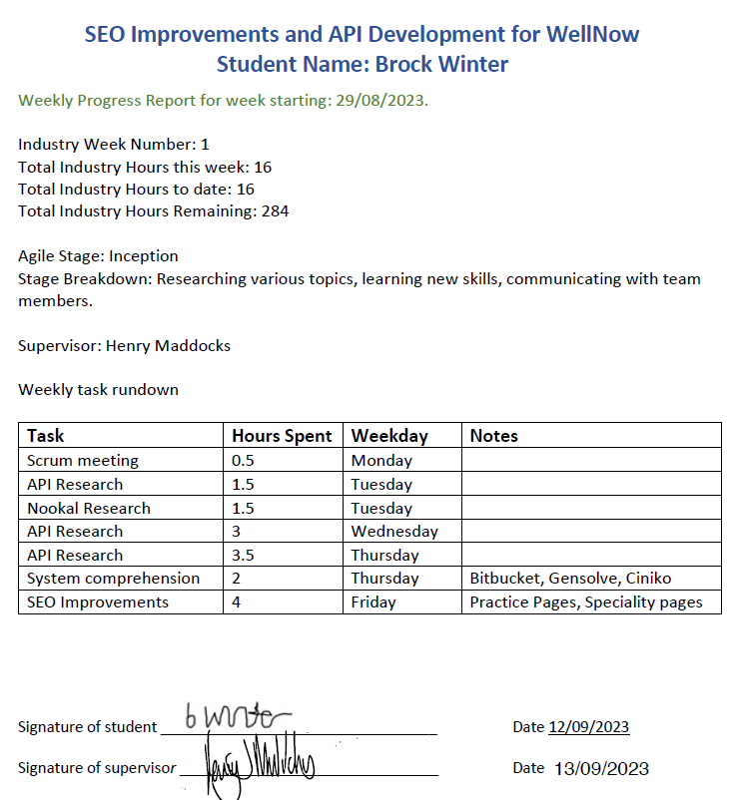

**Figure 2**   
*Academic Week 5 Progress Report*

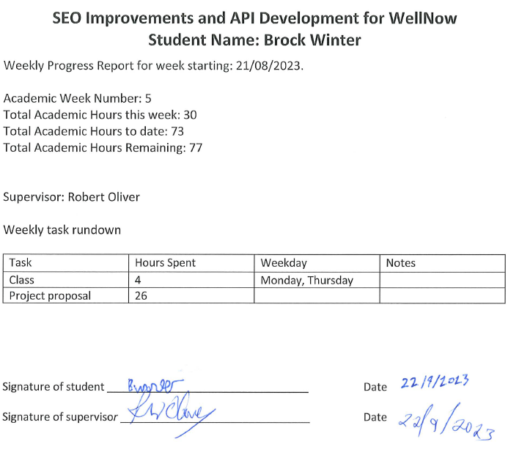

# Student Skills

Thissection explains what general skills, ICT skills, and skills learnt from Level 6 and 7 courses are required to complete this project. It also discusses how new skills will be learnt.

## General Skills Required

* Time management skills.
* Good listening skills.
* Ability to learn.
* Ability to problem solve.
* Ability to work under pressure.

## ICT Specific Skills Required

* An understanding of multiple programming languages.
* Experience with MVC (Model View Controller) structure.
* Experience with unit testing.

## Skills from Relevant L6 and L7 Courses

**Best Programming Practices (C# .NET)**

This class gives the ability to code at an industrial level, ensures the student can use a variety of language features, the ability to plan, design, create, and iterate a prototype system. This class teaches students many fundamentals including variables and data type, constructors, sequencing, access modifiers, inheritance, and many more.

This class taught me important fundamentals that I used when developing components for React. I also learnt proper naming conventions which proved to be very helpful and save time with the code review, it also helped others understand what everything meant when we did peered editing.

The first assessment where you go over many different concepts and coding techniques was great but there was to many, making it hard to remember everything. I believe the students would benefit from course either being longer or the content of the first assignment being shorter. It would have also been nice to be able to connect with different coding languages, for example how I had to connect to Ruby with React while using Tailwind CSS, typescript, and JavaScript.

**Software Development Project**

This course helps students effectively manage and complete all stages of a software development project. This course enables students to analyse and evaluate a client needs. Teaches students to use an appropriate development lifecycle for designing and producing iterative prototypes. At the end students will be able to use relevant technologies and tools to produce and deploy fully functioning software applications.

This course helped with determining the client’s needs and documentation. The course taught us about wireframing, storyboarding, and iterative prototyping which helped to contributes to the creation of user-friendly web pages. The course's attention the projects management, risk analysis, and quality assurance helped significantly when it came to creating the report. It taught me how to spearhead my own project which proved to be really beneficial.

I believe that having a larger focus on the work itself would help considerable. You could remove quality assurance and maybe add it to risk management creating more room for what you could consider industry work/project work. There may also be other sections that could be combined. I just don’t see this why writing a massive report was needed when it could have also been done with a test that questions the student on what they should do or how they should act when faced with certain situations. In my opinion, most industry cases we won’t be writing a 70-page report so this should be changed to something like a test that challenges a student intellect.

**Best programming Practices (Server-side Programming PHP)**

This course helps students with demonstrating their ability to code to at industry standards, implement a prototype system, and apply their knowledge of standards and tools to construct complex systems. This course covers many essential topics, consisting of achieving language competence at an industry standard, database connectivity, form handling, RESTful web services, AJAX, cookies, sessions, arrays, tables, file handling, templates, regular expressions, security measures, password handling, encryption.

I found this course to be rather advanced and extremely helpful. It taught me essential knowledge when it comes to connecting multiple technologies. Just like the c# course this course taught a wide range of techniques that where useful in developing the project. Nookal’s API was also in PHP which made things easier.

My advice is that this course needs to be longer and teach more about the terminology that gets used in the industry. Another thing that I believe should be changed in this course and others is the hours. Having a one 3-hour or two 2-hour class’s a week and then the rest of the time being study becomes difficult. I believe it would be better to have more scheduled time for classwork whether that is an optional class or additional class I don’t know. But I personally don’t like it.

**IT Governance**

This course helps student to strategically analyse and evaluate IT systems and solutions within organisations. It teaches students to examine and employ information technology governance standards and frameworks. You also learn to strategically analyse and evaluate options to develop long-term plans for deployment of technology. In this class you create an IT Governance framework, to facilitate effective IT deployment.

The research we did analysing why projects fails was useful knowledge to have when planning the completion of tasks and looking at the work that was done. This ensured a higher likelihood of success by knowing how others have failed. This course provided me with important knowledge about structured frameworks and sets of processes that guide decision-making and oversight. This ensured that I had proper focus and direction. I also liked the weekly progress reports that we had. It was like a simulation of what would happen in a real work environment.

I believe that the Moodle page should be better structured like the other classes. This class could also be combined with another class such as the Software Development Project. The structure of the assessment guides doesn’t look as formal or updated as the other courses assessment guides. There could have also been a description explaining why these assessments would be useful to us but it’s not 100% necessary or needed.

**Web Development**

This course helps students with the skills and knowledge necessary to develop and administer moderately complex websites. Throughout the duration of the program, students will focus on mastering various aspects of website development, gaining the ability to demonstrate technical responsibility across all stages and iterations of a website development project. The curriculum is structured to cover essential topics such as HTML, Advanced CSS, CSS preprocessors, HTML/CSS frameworks, content management systems, web server administration, usability design, and accessibility.

I did use the skills I learnt from the first half of this course when developing web pages. We had a look a bad website which did help to give information about the dos and don’ts of website creation. I learnt about not over cluttering and having a decent flow for the content.

This course was extremely difficult and not in a good way. I came across multiple errors and with trying to follow the poorly structured instructions on Moodle. You would start following a tutorial then run into an error, then you would need to go back the Moodle to figure out what went wrong. It could have just had one document explaining what to do. I don’t like going to a class where we basically only follow tutorials. I would have preferred to write an essay about SEO and what techniques are used to increase search engine optimisation. I would have also liked more tips on styling websites, like how to make them look good.

## Approach to Learning New Skills

New skills were learnt either through a teacher or an industrial team member, online developer documentations, or online tutorials.

### Summary

The skills that were needed was the classes listed above as well as many programming languages, and a large list of personal skills such as communication, time management, problem solving, being flexible, and more. My programming courses taught me important fundamentals that helped me learn new programming languages quicker.

I already had most of these skills, but they definitely improved over the duration of the project. The only skills I didn’t have were the programming languages listed below.

I have been taught React, Typescript, and JavaScript trough Luke when he was available. I was taught about the structure of the development environment, about APIs, and Ruby from Henry. I also learnt a lot about SEO from Sam.

### Reflection

The academic skills did help in some regards, but I still felt that I was struggling in many areas. For example, it would have been great to see an example of a working development environment while I was studying. This would have better prepared me for starting within a company.

With the help of the senior developers, I was able to learn new skills that I needed. I would have liked to have been taught more advanced programming where I would be working inside a massive development environment with other developers.

This project has been an incredibly learning experience and has taught me many personal and programming skills.

# Project Plan – High Level

This section goes over the major phases of the project. There is also a timetable showing when key events should be accomplished.

## Phases

The project is made up of 6 two-week sprints.

There are six tasks that will be completed during these sprints:

* Necessary Research
* SEO Improvements Services pages
* SEO Improvements Practices pages
* Nookal API Integration
* Setmore API Integration
* Calendar Syncing (additional task)

**Table 8**

*Industry Work overview*



**Table 9**

*Search Engine Optimisation Work Breakdown*



**Table 10**

*Nookal API Integration Work Breakdown*



**Table 11**

*Setmore API Integration Work Breakdown*



**Table 12**

*Acuity API Integration Work overview*



Note: See page 7 for more details.

**Table 13**

*Calendar Syncing Work Breakdown*



**Table 14**

*Other Tasks Work Breakdown*



## Development Lifecycle

* The code gets created in Visual Studio Code.
* Then it needs to be committed and pushed to a branch on Bitbucket.
* After that a pull request is created to merge into the main branch.
* It then gets deployed to a test deploy on Vercel.
* Then it gets reviewed and approved or denied through either Luke or Henry.
* Until finally the pull request is approved, and it gets merged into the main branch.
* Then it is deployed to production, where it is hosted on First Domains.

Sprints 2-6 will involve using the development lifecycle to develop code.

## Sprint One Necessary Research

The first sprint is about researching different APIs to figure out what they offer and how to best utilise them for WellNow.

I will also be getting familiar with the different tools, start setting up a development environment needed, and meet the people I will be working with.

## Sprint Two and Three SEO Improvements Services Pages

This stage will start with getting the content created and checked, then developing a working model in React using Visual Studio Code and styled using Tailwind CSS. After that there will be iterations, and continuous feedback loops to finalise the design and content.

## Sprint Four SEO Improvements Practices Pages

This sprint will be very similar to the last two sprints with the addition of using an API to pull information from the Ruby database to generate the content for these pages instead of doing it manually.

## Sprint Five Nookal and Setmore API Integration

This sprint will involve utilizing the existing APIs as a base and adapting them to Nookal and Setmore. This will be done using the information gathered in sprint one.

## Sprint Six

Sprint six will involve adding the option to add to calendar after a user makes a booking through WellNow. This will most likely be done by using both React to create the button that connects to an API for Google Calendar.

## Timetable

**Table 17**

*Weekly Timetable*



**Table 18**

*Weekly Timetable Key*



Most of the work will be completed at the office in K-block at Ara. This is to enable a positive and productive work environment, while reducing distractions.

**Table 15**

*Industry Burndown*



**Table 16**

*Academic Burndown*



Note: Weeks 17 and 18 where estimated

## Burndown Charts

### Industry

**Figure 3**   
*Industry Burndown Chart*

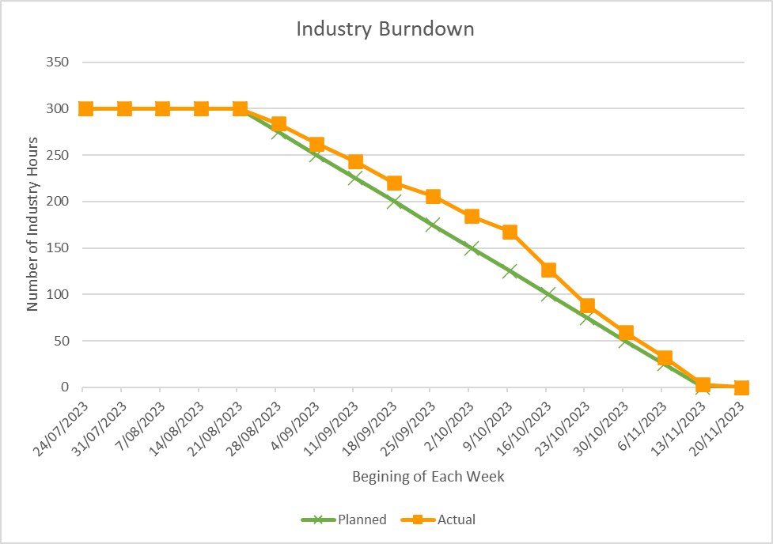

### Academic

**Figure 4**   
*Academic Burndown Chart*

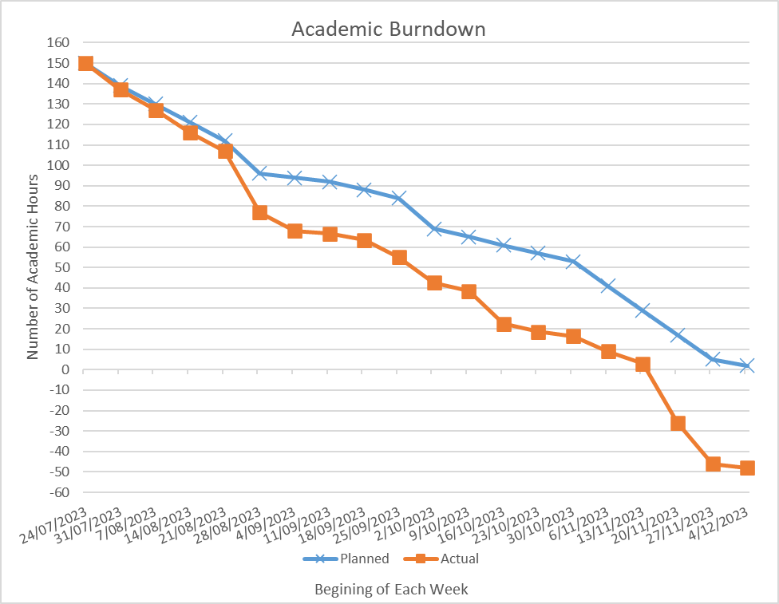  
This figure shows the planned hours spent on academic work and the actual hours spent. I ended up spending a considerable amount more time on academic work to ensure an optimal mark.

## Resources/Access Required

Notion: A kanban way of displaying tasks and objectives.

Slack: Used as a tool for communication.

Google Meet: Used for weekly industry scrum.

Bitbucket: a Dropbox tool used for uploading work.

Visual Studio Code: a code editor tool.

Insomnia: a tool used for connecting with API keys.

Vercel: used for creating a testing environment.

Other tools used: Notepad++, Excel, YouTube, Google, Word, Gmail, Moodle, Adobe.

## Detailed Project Plan

**SEO Improvements**

Create content that ranks highly in the Google search results for queries where we expect the next step someone is going to take is to find available appointments. Research will be conducted in order to find the best possible solution.

**API Integrations**

Build an API integration as per the existing integrations with Gensolve and Cliniko.

This will require researching the required fields and elements to call. Then using the existing developer documentation create the APIs. The code will then be run through existing test. After that the APIs will be reviewed and uploaded for review before finally being launched.

Refer to the Appendix to see the work completed.

## Reflection

The initial project plan was not very effective and was severely lacking. It was very rushed, and I didn’t at that stage know enough about the project to make it very detailed. I had issues with trying to follow the projects originally plan. Tasks seemed to be far more difficult to complete then I had originally thought, causing me to spend more time and cut away time from other areas.

Having a direction of where to go was helpful but could have been done better. It felt impossible to follow the planned sprints as tasks just seemed to take longer and longer to complete. This forced me to cut out other areas in hopes of completing others. There were also moments where I had to wait for others whether that be a scheduled meeting or for them to finish some work.

I have learnt that tasks need to be further broken down to understand clearly what needs to be done. This would allow someone to better plan what they are going to need. I should have asked more about the tasks, then broken those tasks down further and discovered what they require to complete and how to complete them.

# Risk Management

This section shows what method was used, why it was used, how often those risks will be reviewed, how to read the risk table, and there will be a risk table.

## Approach

I chose to use the NZ Digital Govt Risk Register to accomplish my risk management. This template had more to offer then the others.

This approach was chosen because I wanted one that allowed me to look a risk and determine its inherent danger, existing controls, and then future improvements. This meant that the risks were rated without any controls, with existing controls and future controls.

I made two small changes to the framework. The first was changing the impact rating of severe to catastrophic. This made it sound like it was more project ending then just severe. The second change I made was adding the value happened to the risk’s likelihood. This was to show if a risk had occurred.

There will be major updates made at the halfway point and at the end of the project. There will also be smaller changes made whenever a risk factor changes. For example, on the 12/09/2023 through to the 19/09/2023 I was sick so that meant that the risk table needed updating and the risks likelihood needed to be changed from possible to happened.

There are three main sections to this risk management framework. The first section describes the risk and talks about the inherent risks. The second section lists existing controls and the residual risk value. The final section states risk improvements and the target risk value (NZ Digital Govt, 2022).

## Risk Table

**Table 19**

*Risk Table part 1*



Note: this is the first part of the risk table, it describes the risk, its likelihood, and impact.

**Table 20**

*Risk Table part 2*



Note: this is the second part which describes existing controls and the effect of the controls on the risk’s likelihood and impact.

**Table 21**

*Risk Table part 3*

|  |  |  |  |  |
| --- | --- | --- | --- | --- |
| **Risk Improvement Plan** What additional action (if any) should be taken to further manage this risk? | **Target Date** | **Target Risk** (After risk improvement, if any) | | |
| **Likelihood** | **Impact** | **Risk Rating** |
| Keep virtual copies. | 8/09/2023 | Rare | Major | Medium |
|  |  |  |  |  |
|  |  |  |  |  |
|  |  |  |  |  |
| Keep additional copies | 8/09/2023 | Rare | Minor | Low |
|  |  |  |  |  |

|  |  |  |  |  |
| --- | --- | --- | --- | --- |
| **Risk Improvement Plan** What additional action (if any) should be taken to further manage this risk? | **Target Date** | **Target Risk** (After risk improvement, if any) | | |
| **Likelihood** | **Impact** | **Risk Rating** |
| Keep virtual copies. | Continuous | Rare | Major | Medium |
|  |  |  |  |  |
|  |  |  |  |  |
|  |  |  |  |  |
| Keep additional copies, backup and save frequently | Continuous | Rare | Minor | Low |
|  |  |  |  |  |

Note: this is the third part which describes future improvements and the effect of the improvements on the risk’s likelihood and impact.

## Halfway Update

The first change was in the second week when I ran into an error with Windows Subsystem for Linux (wsl) where I wasn’t able to fix the problem by myself. This issue was fixed with a few Google searches and assistance from Henry. This made me change the likelihood to happened and the risk impact to minor. This resulted in the risk rating being high, which I didn’t agree with, so I changed the calculations so that the risk rating would be medium.

The second change was during the fourth week where I changed the likelihood for catching Covid/cold to happened after I got sick during the third week of academic work.

While creating the halfway reports I realised that keeping up with the academic work was starting to become an issue. On the 13th of October I had to deliver the halfway reports, emerge statement, industry supervisor and academic supervisor halfway assessments, and methodology essay part A. This made me add another risk to the risk table which I called academic work overload.

## Final Update

The only change that needed to be made was to do with inadequate skills/knowledge which I originally called inadequate skills. Here I changed the impact from minor to major. I know it is a massive change, but I believe it was necessary given that it was the main reason why the project was finished in an incomplete state.

Refer to page 12 and 13 for more information.

I think this method of handling risks was great, but sadly I wasn’t able to put as much time into it as a should have. This way of recording risks was very effective. I was able to show the risks initial rating, its rating after mitigations, and its rating after future mitigations.

The only downside I saw to this model was having to set the risks impact. The reason why I am saying this is because an impact can differ in certain circumstances. For example, having a lack of knowledge/skills was very difficult to measure the impact for until it had already happened. I don’t think that was the fault of the risk model I just think it was difficult to read certain risks. In a similar way if I were to just put earthquake as a risk without specifying the magnitude I would be in a similar situation.

For the future I believe risks should be assessed more frequently. Also, a larger list of risks at the start of the project would have helped to implement risk prevention sooner.

# Quality Assurance

This section details the quality assurance method, how processes will be followed, how variables will be controlled, and quality will be assured. This is to ensure that the projects deliverables meet the academic and industry standards and the methods used to complete the deliverables are appropriate.

## Approach

The selected approach is a variation of the Virginia Tech Quality Assurance table.

This method of quality assurance was chosen to enhance the quality of code created.

This table will be reviewed whenever a deliverables quality needs to be tested.

This table states the deliverable, the step order, the task, participants, and its completion date(Virginia Tech, n.d.).

## Quality Assurance Table

**Table 22**

*Quality Assurance Table*



Refer to appendix D to view web page design review.

## Notes about Quality Assurance Tasks

* The code gets created in Visual Studio Code.
* Then it needs to be committed and pushed to a branch on Bitbucket.
* After that a pull request is created to merge into the main branch.
* It then gets deployed on Vercel.
* Then it gets reviewed and approved or denied through either Luke or Henry.
* Until finally the pull request is approved, and it gets merged into the main branch.

## Test Plan/Scenarios/Cases

WellNow has an automated test suite called RSpec that the developer maintains and adds to as the are developing new code. This test suite can be run at any time by the developer and is run automatically whenever code is pushed to the source control repository. Code is not accepted if these tests don’t all pass.

Once the developer has completed their task there is a code review stage. A senior developer will inspect the change to make sure it does what is expected, and the code is of a high standard. Once the code has been approved it can be merged into the main source branch.

Melanie carries out user acceptance testing and when she is satisfied the code change will be deployed to production.

**Reflection**

This method didn’t feel super effective. Most of the tasks were either removed or added compared to the original quality assurance model. This could have also just been the case of poor planning which definitely would have contributed.

Recording what quality assurance steps needed to be taken was a good idea but it was hard to predict what quality assurance tasks needed to be done. I believe that more tasks would have been added if given the opportunity to continue since I was just about to wrap up the development for the SEO page.

# Methodology

This section discusses the methodologies used, what they do, and their pros and cons. The methodologies that were chosen where Agile, Scrum, and Kanban.

## Essay Summary

This project used Agile methodology. Agile helps to encourage healthy communication, teamwork, and continuous improvement. It does this by breaking large tasks into smaller more manageable ones (Wrike, n.d.). Agile is about taking a large project and then splitting it into multiple smaller tasks. Tasks are first planned, then executed, and evaluated continuously until the client is satisfied. This differs from the traditional waterfall approach where there is only one iteration (Atlassian, n.d.).

Notion which is a Kanban board was also used for visualising project management (Martins, 2022). There were also Scrum meetings that encouraged users to challenge themselves, focus on tasks that are necessary, commit to achieving business objectives, respect fellow scrum members, and be open with the problems and performance (Scrum, n.d.).

The strengths of Agile are having good results, focus, and flexibility. Cons of Agile are split focus and the fact that you are reliant on the client’s feedback. Scrum's pros include improved results and resource management, while cons involve challenges for large teams. Kanban is praised for project visualization but may become overwhelming.

WellNow emphasizes Agile's role in enhancing a healthcare platform. Agile, Scrum, and Kanban contribute to task breakdown, continuous improvement, and collaboration.

In the critique, strengths include collaboration, skill enhancement, task breakdown, and continuous improvement. Weaknesses involve incomplete utilization of Agile stages, synchronous collaboration challenges, and delayed development setup. Areas for improvement include tailored Agile adaptations for complexity and enhanced collaboration strategies.

In conclusion, Agile, Scrum, and Kanban prove effective for collaboration, adaptability, and continuous improvement. The essay highlights a holistic approach to project development but acknowledges areas for improvement and tailored adaptations in future projects, emphasizing the need for balance and flexibility.

Some learnings for the future are changing Agile to specifically match the complexity of my project. This way I can use a good base and shape it into what would work best for me. I also believe that there should have been daily or bidaily meeting to give updates and reassure the deliverables and where the project is heading.

# Professionalism

This section goes over academic and industry professional standards, correct ethical behaviour, and relevant legislations.

## Professional Standards

The industry and academic standards will be met by having a clear understanding of the projects deliverables, goals, image, and always conducting myself in a professional manner.

### Reliability and Accountability

Submissions will be made on time, any agreed upon classes/appointments/meetings shall be fulfilled or given notice of absence, always ensure proper usage of time, all feedback and comments shall be taken into careful consideration, I shall also be accountable for my own actions.

### Communication

I will speak clearly, with appropriate language, while being considerate of others. I will also ensure that others feel welcome and comfortable discussing various topics with me.

### Attitude

I will respect the others’ opinions and point of views, be polite, avoid negativity, and not hinder others with personal issues.

### Teamwork

I will contribute to the ideas and projects of my workmates. I will aid in whatever tasks I’m able. I will not hinder or dissuade others.

### Motivation

I will have a positive outlook on this project even in difficult situations. I will always try my best to achieve the projects goals.

### Open to Learning

I will actively aim to increase my skillset, aim to challenge myself, and demonstrate my abilities to ensure that I’m always improving.

## Relevance of ITP Code of Ethics

I will follow the ITP Code of Ethics to ensure that the project runs smoothly. This will ensure a certain level of professionalism and correct behaviour towards others.

(IT Professionals New Zealand, 2017)

### Good Faith

I will treat people with dignity, good faith, and equality, without discrimination, and have consideration for the values and cultural sensitivities.

### Integrity

I will demonstrate integrity, dignity, and honour when in the presence of others. I will be honest, treat others with respect, and ensure professional judgement.

### Community Focus

I will be put the community and public interest before my own interests.

### Skills

I will utilise my skills and knowledge for the betterment of my client.

### Continuous Development

I will continuously expand my skillset throughout my career to better contribute to associates and other professionals.

### Informed Consent

I will ensure that the client is notified of any environmental, social, or legal consequences that may occur.

### Conflicts of Interest

I will inform the client of any conflicts of interests which may occur causing an effect on the quality of service or my impartial judgement.

### Competence

I will only provide services or advice within my area of expertise.

## Relevant Legislation

This section describes how the privacy/confidentiality, copyright, and patents legislations will be upheld.

### Privacy/Confidentiality

Personal information such as name and contact details will be accessible during this project making me come under The Privacy Act of 2020.

This ensures that a customer knows when and why the information is being held, they will know the use of their data is professional, that all data is in a secure location, and is available to the information provider.

### Copyright

Copyright applies to anything created in the last over 50 years such as code, websites, tests, etc.

### Patents

The right to prohibit others from selling, creating, or using what you have made for up to twenty years.

## Reflection

I treated everyone with respect, never judging anyone for a mistake they might have made. I took their feelings into considerations when I was communicating with others and writing my responses.

The weeks I went into the office I was always on time or early, I was always well dressed and professional. Even the week I was sick I still properly communicated with others and continued working.

When designing the web pages, I never took the easiest route, I always did what was right to ensure the customers would be satisfied with the product.

I utilised my skills and knowledge to work on the project and strived to achieve what the client wanted.

Throughout the project I constantly had to push myself to learn more. For example, I had never done any React or Ruby nor did I know what API even meant before starting this project. This meant I had to expand my skillset to be able to contribute to the project.

There was only one instance where a confidential data field had to be removed from the practitioner API call to ensure data safety.

I did end up having to inform the client of some matters to do with the quality of the product. This involved me displaying the work I had done and explaining what was being difficult and might not be able to be completed.

I never once questioned why they ran the company the way they did or why both the co-bosses took vacations while I was working for them. Nor did I question the fact that they would appear hours late or some days not at all.

My approach to ethics was to make myself look as professional as possible and good in the eyes of the client. This kept me in good terms with those I was working alongside. But I also ended up keeping my opinion to myself in some situations when I was frustrated.

In the future I don’t believe I would change anything. I believe the way I did everything was the right way to do it.

# Sustainability, Inclusive Practice and Te Tiriti o Waitangi

This section goes over relevant principles for the project, how to look after resources and the environment, the write for making decisions, how stakeholder connections are maintained, and how the Māori language should be used.

## Relevance of Principles to Student and Industry

These principles will be addressed when there is a relevant situation. I will also make sure to treat everyone with respect and equality, while ensuring that the environment is safe, and the stakeholders are happy.

### Kaitiakitanga

The Māori definition of how people are connected with nature.

This project will not hinder people, nor will it take up considerable resources, or damage the environment.

### Rangatiratanga

Defines how the Māori have right to own property, goods, and freedom of choice.

The projects participants shall maintain all rights for making their own choices and won’t hinder the choices of others.

### Whanaungatanga

Defines the relationship between people.

Scrum meetings will be held to ensure connections are maintained with the stakeholders while the project is running.

### Mana Reo

Defines the importance of communication.

The project members will be constantly communicating together to ensure proper coordination and teamwork.

The Māori language will be used only whenever it is directly necessary or to be polite in an email.

### Reflection

I tried my best not to hinder or take too much time from others in the industry. For example, Luke had a very limited number of hours he could work, and he also had multiple tasks to do so I needed to spend more time finding out the answers myself.

I never tried to force anyone to do anything they didn’t want to do.

I always kept a respectable relationship with those I worked with, never criticizing, or insulting them.

There was an extensive list of communication weather that is the weekly development team meetings.

My strategy towards Sustainability, Inclusive Practice, and Te Tiriti o Waitangi involved presenting myself in a highly professional manner to allow clients the freedom they wanted and maintain positive relationships with colleagues.

However, like mentioned in the ethics reflection there were instances where I chose to withhold my opinions when I was in frustrating situations.

Looking ahead, I don't foresee making any changes as I believe my approach was the most effective and appropriate for the circumstances.

# Self-Assessments

Halfway Self-Assessment

Industry

**Table 23**

*Industry Self-Assessment*

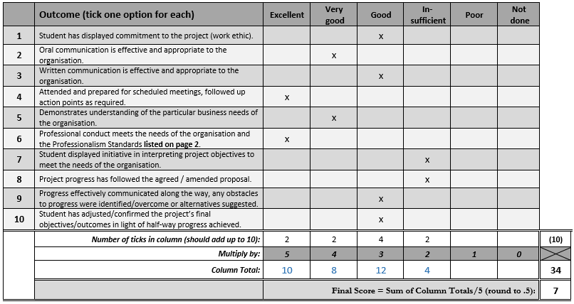

Academic

**Table 24**

*Academic Self-Assessment*

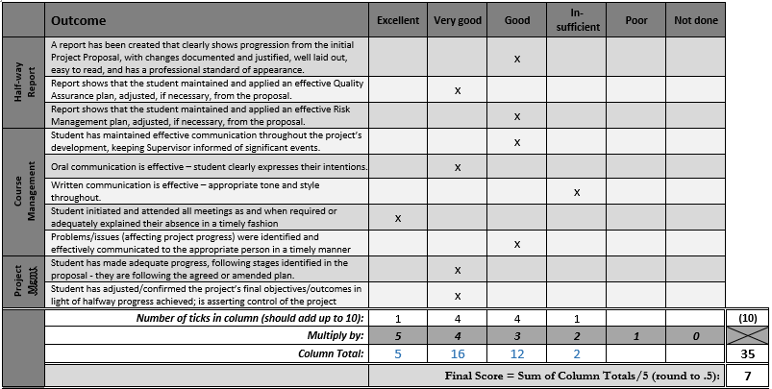

# Self-Assessments

Final Self-Assessment

* Course Management: 3 marks.
* The Project: 25 marks.
* Analysis of relevant level 6 and 7 course content: 3 marks.
* Quality assurance programme: 2 marks.
* Risk management programme: 3.5 marks.
* Methodologies essay/report: 3 marks.
* Report: 8 marks.
* Panel: estimated 7 marks.
* Poster and short paper 4 marks.

Total: 58.5

# Reflections

This section discusses the approach to taking notes, approach for recording lessons learned, and general reflection.

## Approach

At the end of the day what tasks I work on get added to an Excel spreadsheet that shows, what I researched/worked on, how long it took. I will also be taking into consideration the projects risks, quality assurance, methodology, and professionalism while taking notes. This will enable me to more easily complete additional tasks, make later reports and papers easier.

At the end of the two-week sprint cycles there will be a sprint retrospective where I will record what worked well in the Sprint, what could be improved, anything that was surprising, what I have learned, and goals I have for the next sprint.

## Final Summary

This project involved creating one services home page with seven individual services pages. It also involved creating one clinic list page with many different automatically generated clinic pages. These web pages involved using React, Typescript, JavaScript, Ruby, and Tailwind CSS. There was also the creation of two APIs that was started.

Throughout the course I communicated with many different people for multiple hours a week. We filled out a variety of reports and signed off multiple time sheets. These stakeholders also taught and helped me with many different tasks.

The skills I most found useful for industry work where the fundamentals I learned from both PHP and C# classes. I also found that the Software Development Project class prepared me for the academic work. New skills where either learnt from a senior programmer or from an online source.

The original project plan consisted of four two-week sprints. This didn’t seem possible later on and was changed to 6 two-week sprints. Each sprint was for one specific main deliverable. This changed all throughout the project when some tasks took longer than others.

The approach taken for risk management focused on assessing a risks initial rating then reassessing it with its current mitigations and then reassessing it again with any future risks. This method enabled me to assess risks and plan for what could happen in the future.

I used Virginia Tech Quality Assurance table to ensure the projects quality. This method of quality assurance was chosen to enhance the quality of code created.

I used Agile as my methodology. Agile helped encourage communication, teamwork, and continuous improvement. I also used notion which is a Kanban board, and I had a weekly scrum development team meeting.

My approach to ethics was to always make myself look as good as possible. I would ensure that I was always on time, dressed appropriately, and treated others with respect.

My strategy towards Sustainability, Inclusive Practice, and Te Tiriti o Waitangi involved presenting myself in a highly professional manner to allow clients the freedom they wanted and maintain positive relationships with colleagues.

This course has taught me many programming skills and personal skills. It has enabled me to work in a real work environment among skilled individuals each skilled in different areas. These experiences will stay with me for the foreseeable future. I have learnt about how businesses are run, how to direct and work on a project. Some of my main skills learnt where to do with proper communication, time management, problem solving, flexibility, quality assurance, and risk management.

# References

Ara. (n.d.). *Sustainability Inclusive Practice and Te Tiriti o Waitangi Example*. Retrieved from Ara Department of Business & Digital Technologies: https://moodle.ara.ac.nz/pluginfile.php/1912589/mod_label/intro/Sustainability%20Inclusive%20Practice%20and%20Te%20Tiriti%20o%20Waitangi%20Example.pdf

Atlassian. (n.d.). *What is Agile*. Retrieved from Atlassian: https://www.atlassian.com/agile

Chandana. (2023, July 24). *Scrum Project Management: Advantages and Disadvantages*. Retrieved from simplilearn: https://www.simplilearn.com/scrum-project-management-article

Cohen, E. (2022, November 2). *Pros & Cons Of The Kanban Method In Project Management*. Retrieved from workamajig: https://www.workamajig.com/blog/kanban-methodology-guide/pros-cons-kanban-method

Google Search Central. (2023, 11 17). *Search Engine Optimization (SEO) Starter Guide*. Retrieved 11 25, 2023, from Google Search Central: https://developers.google.com/search/docs/fundamentals/seo-starter-guide

Highsmith, J. (2001). *History: The Agile Manifesto*. Retrieved from agilemanifesto: https://agilemanifesto.org/history.html

Indeed Editorial. (2023, March 10). *14 Pros and Cons of Agile Methodology*. Retrieved August 27, 2023, from Indeed: https://www.indeed.com/career-advice/career-development/pros-cons-of-agile-methdology

Intellectual Property Office. (n.d.). *Copyright*. Retrieved from Intellectual Property Office: https://www.iponz.govt.nz/about-ip/copyright/

IT Professionals New Zealand. (2017). *Code of Ethics*. Retrieved from IT Professionals New Zealand: https://itp.nz/Members/Code-of-Ethics

IT Professionals New Zealand. (n.d.). *The ITP Code of Ethics*. Retrieved from IT Professionals New Zealand: https://itp.nz/Members/Code-of-Ethics

Martins, J. (2022, October 10). *What is Kanban*. Retrieved from asana: https://asana.com/resources/what-is-kanban

NZ Digital Govt. (2022, October 10). *Risk management in the public sector*. Retrieved from NZ Digital Govt: https://www.digital.govt.nz/standards-and-guidance/privacy-security-and-risk/risk-management/public-sector/

Privacy Commissioner. (n.d.). *Your privacy rights*. Retrieved from Privacy Commissioner: https://www.privacy.org.nz/your-rights/your-privacy-rights/

Scrum. (n.d.). *What is Scrum*. Retrieved from Scrum.org: https://www.scrum.org/resources/what-scrum-module

Virginia Tech. (n.d.). *Project Quality Assurance*. Retrieved from Virginia Tech: https://it.vt.edu/projects/project_management/qualityassurance.html

Wrike. (n.d.). *Agile development life cycle*. Retrieved from wrike: https://www.wrike.com/agile-guide/agile-development-life-cycle/

# Appendices

Appendix A – Evidence of Industry Work - Final Report Phase

**Figure A1**   
*Services Home Page – Final Report Phase*

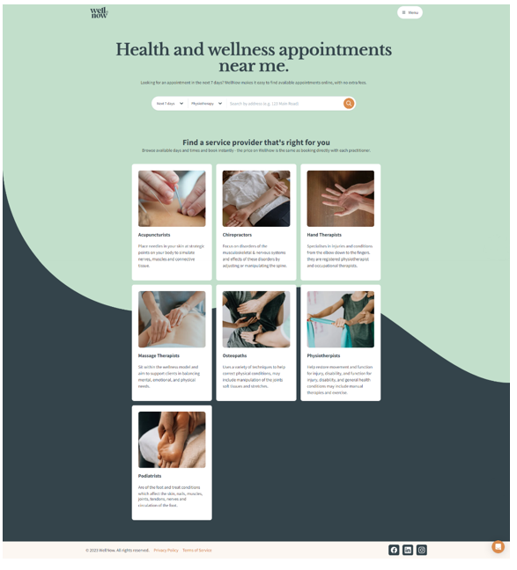

**Figure A2**   
*Individual Service Page – Final Report Phase*

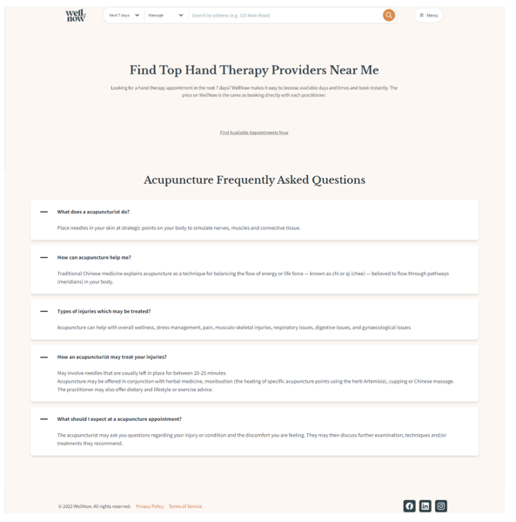

**Figure A3**   
*Clinic List Page – Final Report Phase*

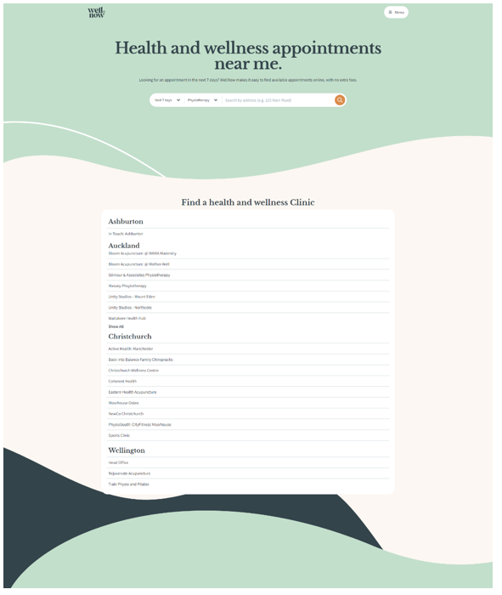

**Figure A4**   
*Specific Clinic Page – Final Report Phase*

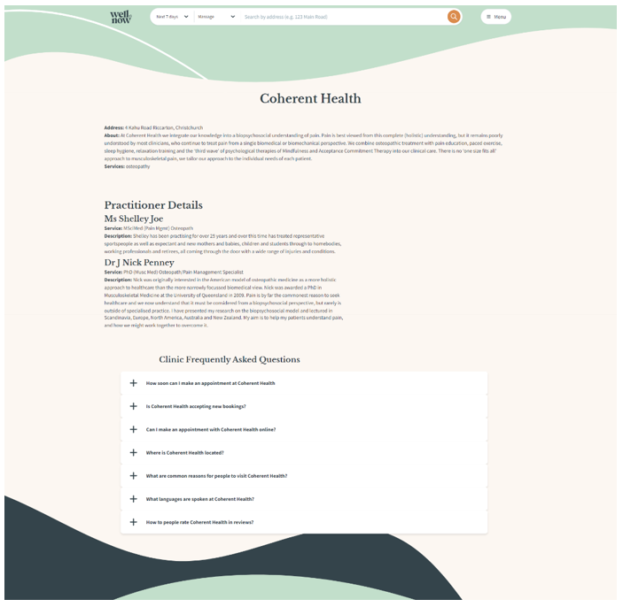

**Figure A5**   
*Nookal API Initial version 1 – Final Report Phase*

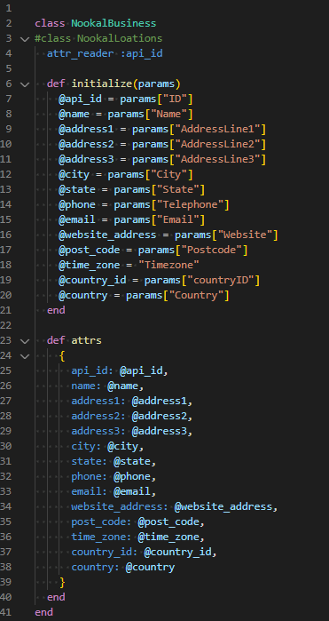

**Figure A6**   
*Nookal API Initial version 2 – Final Report Phase*

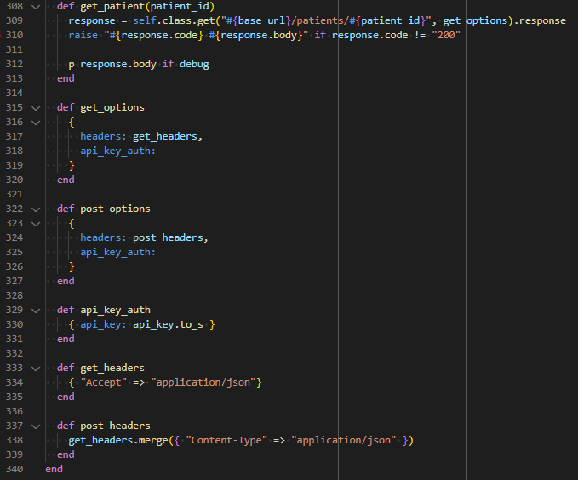

**Figure A7**   
*Setmore API Initial version 1 – Final Report Phase*

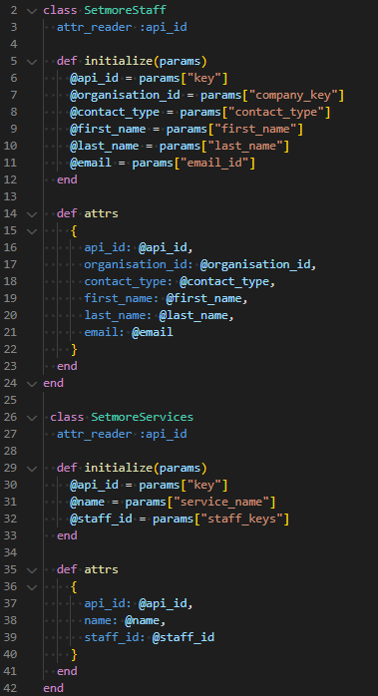

**Figure A8**   
*Setmore API Initial version 1 – Final Report Phase*

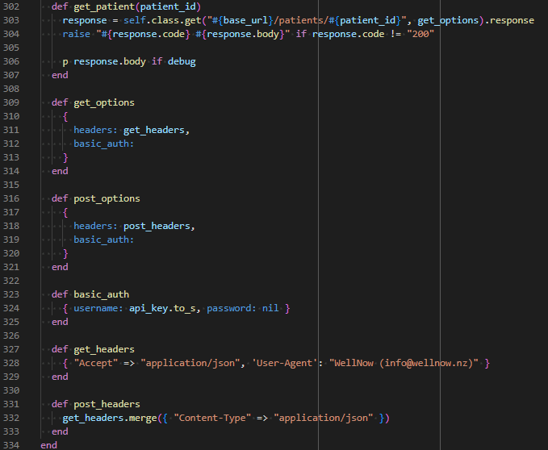

**Figure A9**  
*Additional Business API Call – Final Report Phase*

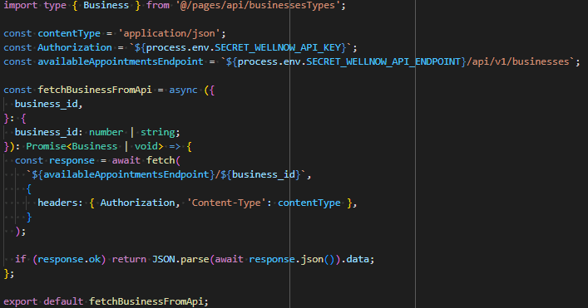

**Figure A10**  
*Additional Practitioner API Call – Final Report Phase*

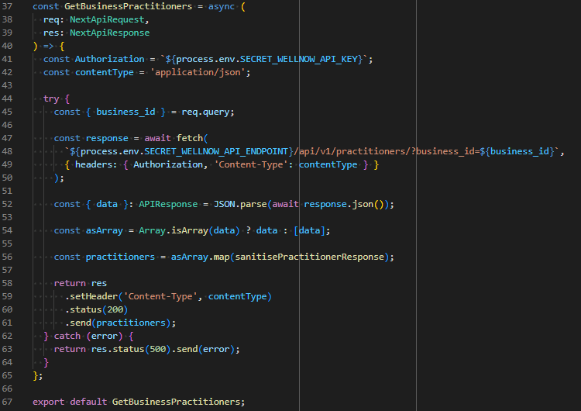

Appendix B – Previous Risk Tables - Final Report Phase

**Figure B1**   
*Initial Risk Table – Final Report Phase*



**Figure B2**   
*Mid-Way Risk Table – Final Report Phase*

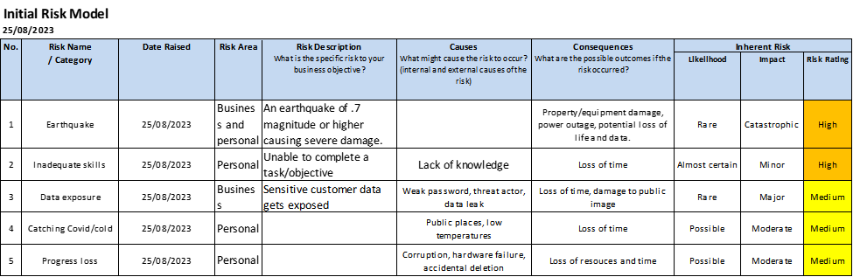

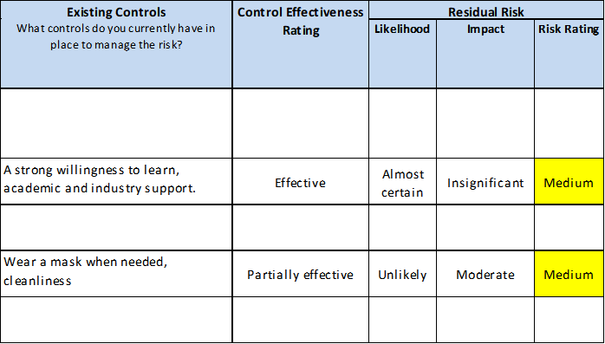

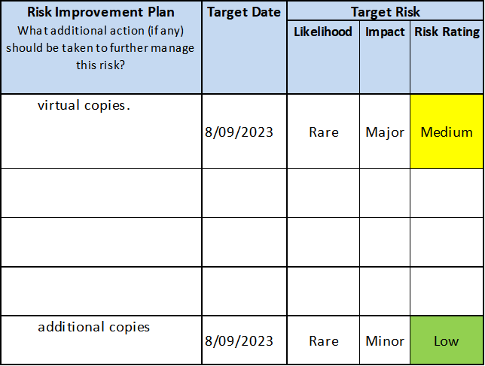

Appendix C – Progress reports - Final Report Phase

**Figure C1**   
*Progress Reports – Final Report Phase*

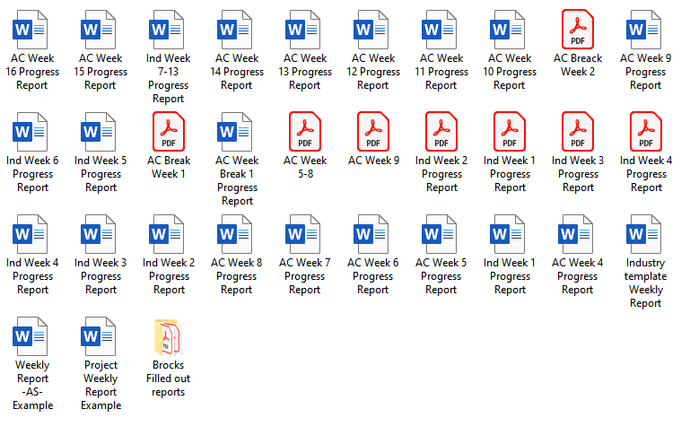

Appendix D – Design Reviews - Final Report Phase

**Figure D1**   
*Services page feedback – Final Report Phase*

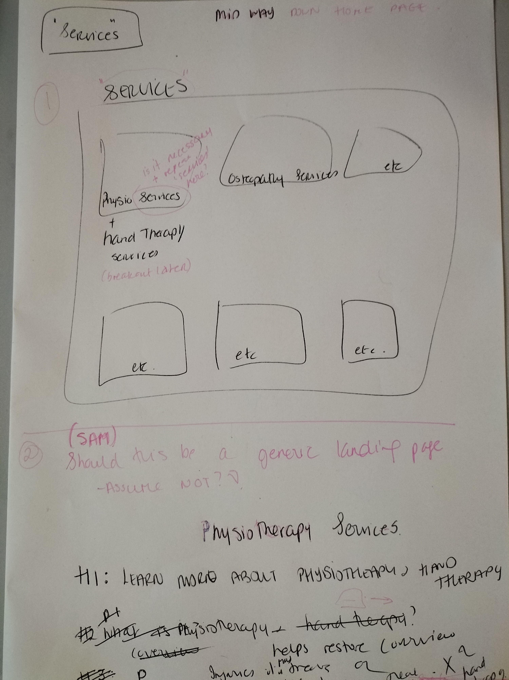

**Figure D2**   
*Services specific page feedback – Final Report Phase*

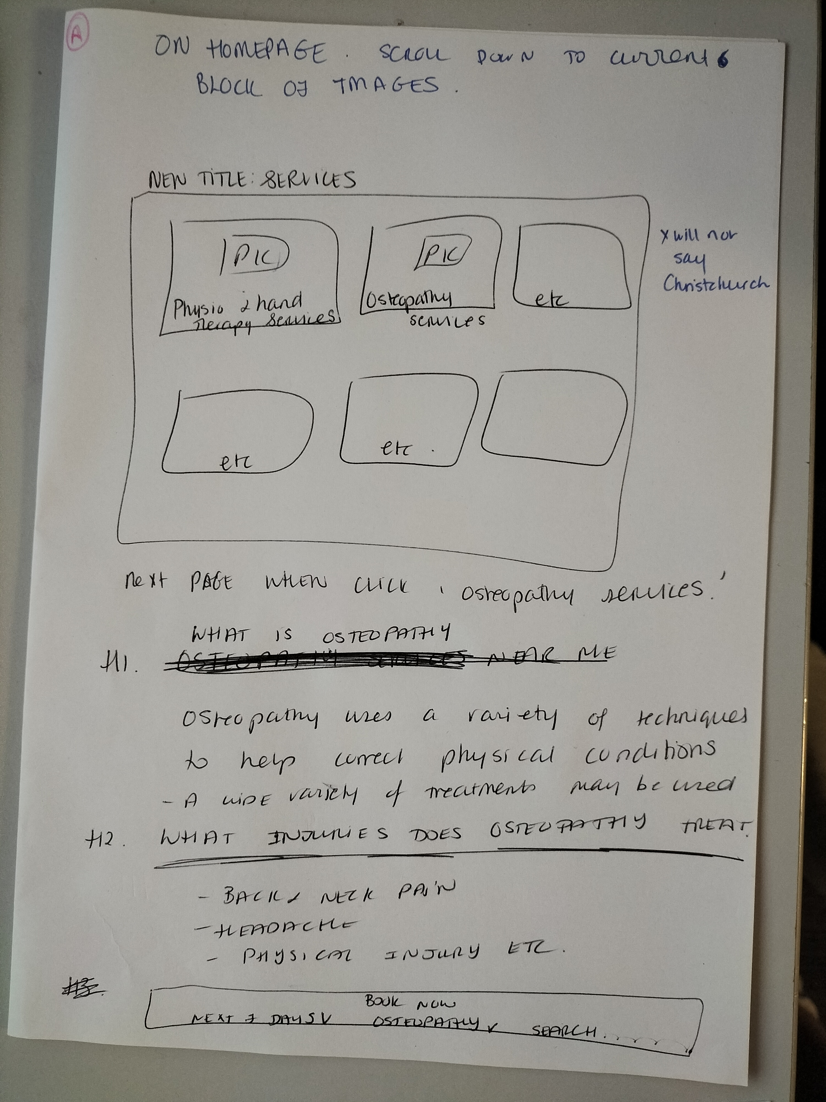

**Figure D3**   
*Clinic page feedback – Final Report Phase*

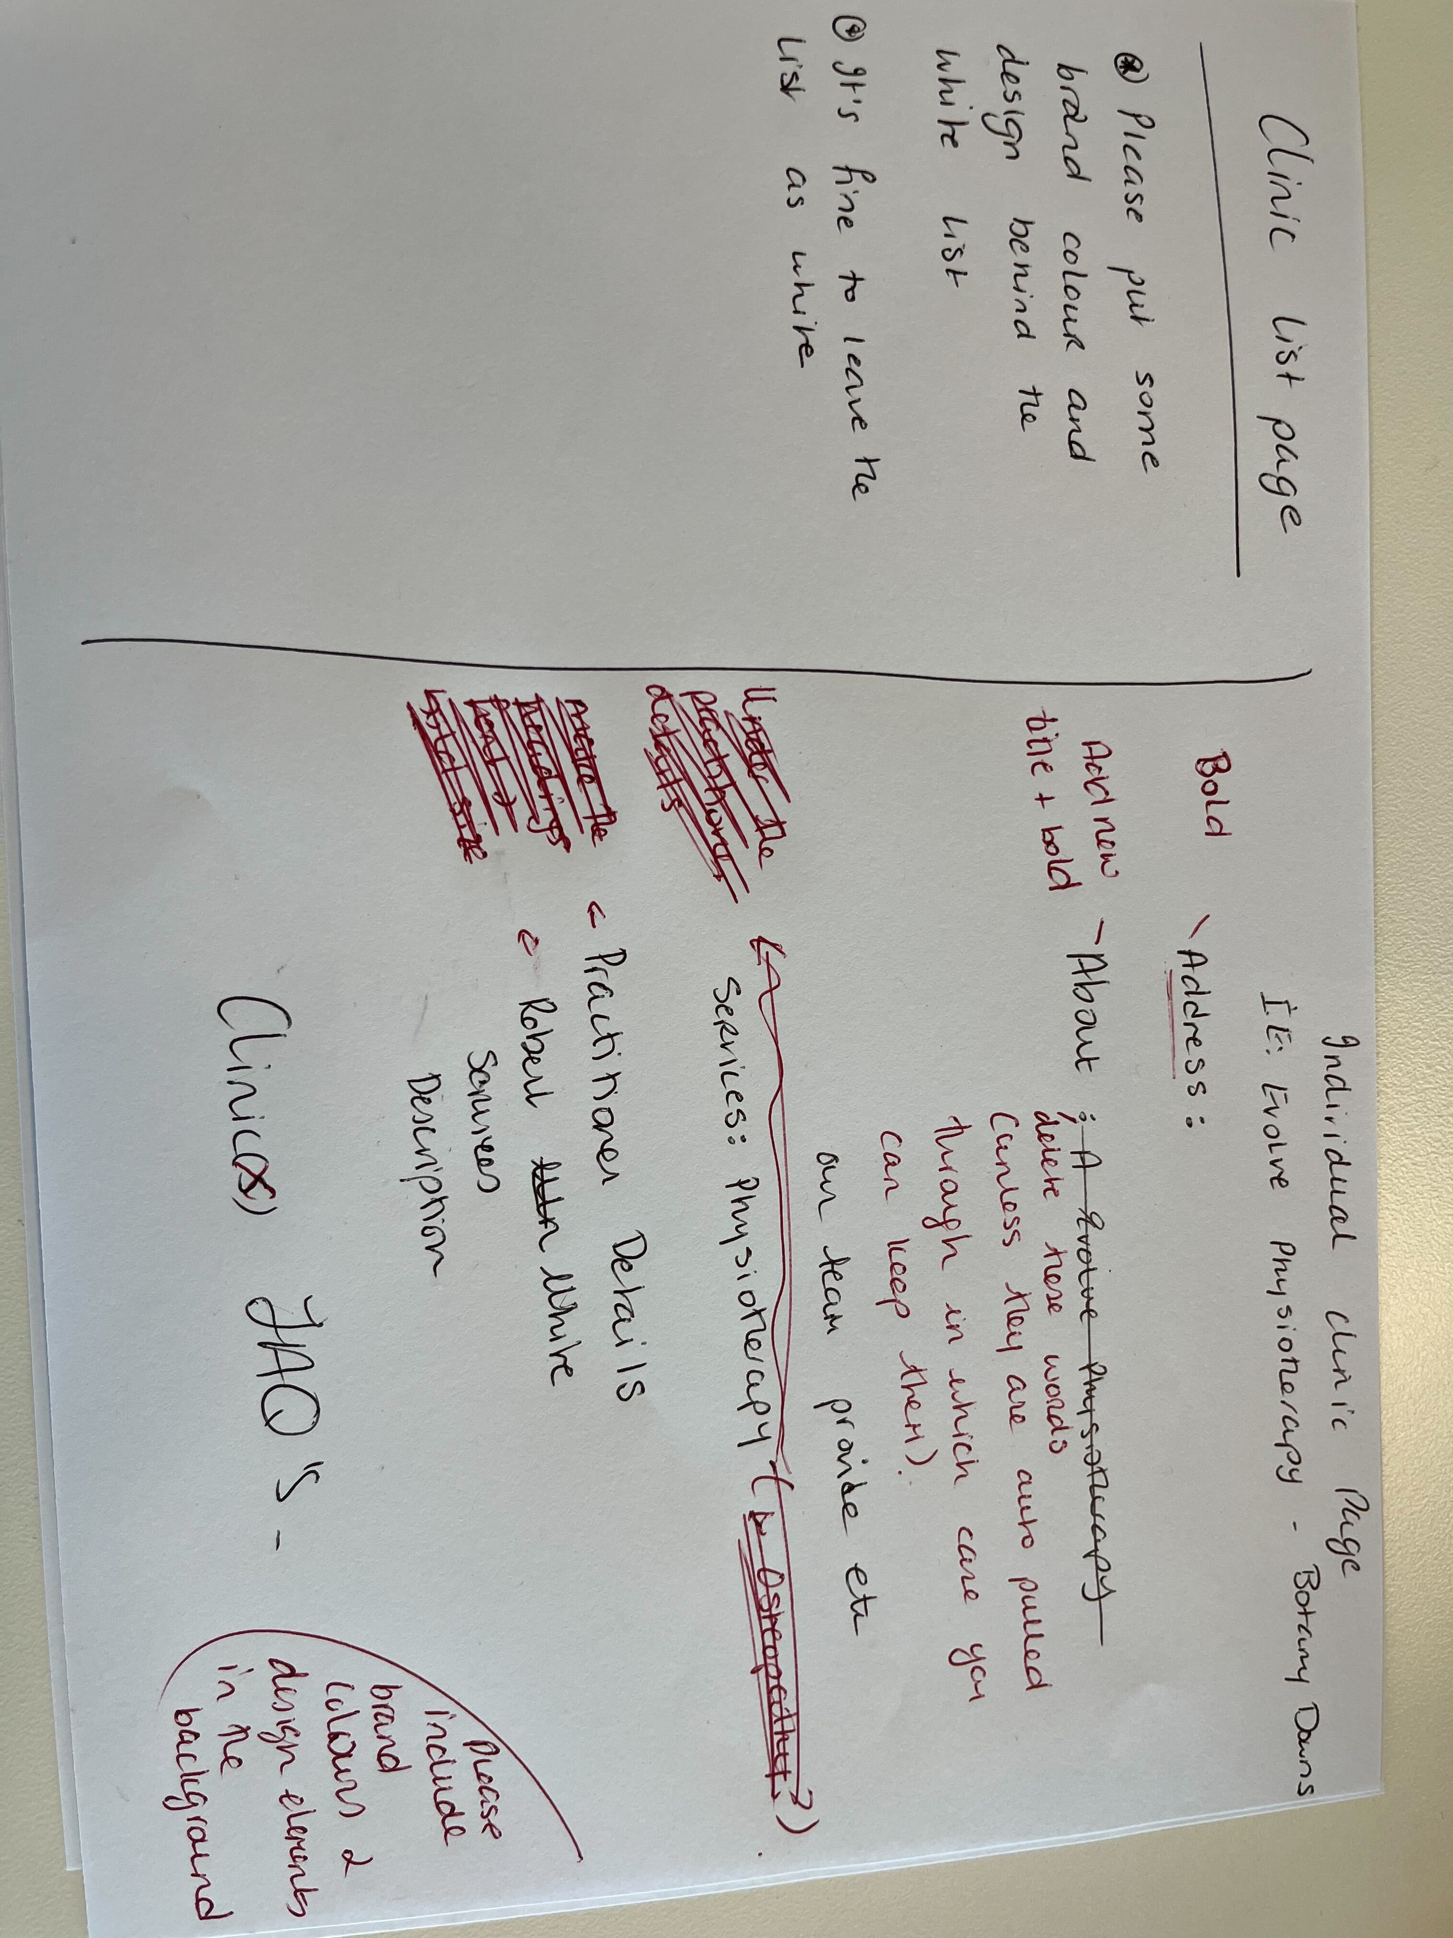

Appendix E – Sprint Retrospective - Final Report Phase

**Figure E1**   
*Sprint Retrospectives – Final Report Phase*

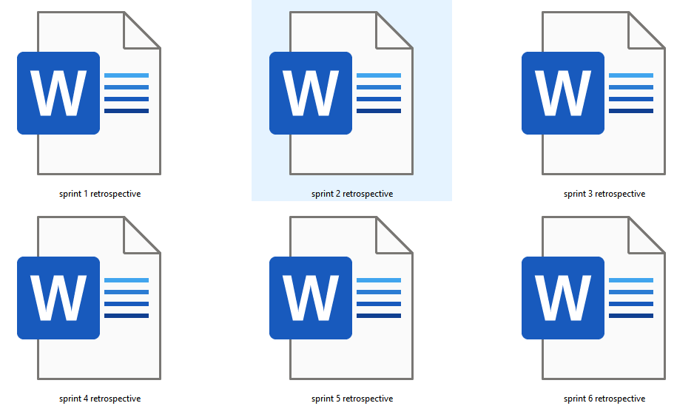

Appendix F – Progress Reports - Final Report Phase

**Figure F1**   
*Progress Reports – Final Report Phase*

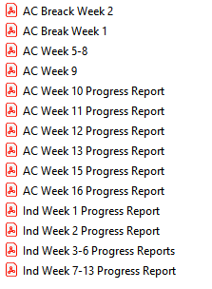

Appendix G – Version Control - Final Report Phase

**Figure G1**   
*Version Control – Final Report Phase*

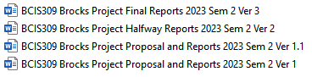

Appendix H – Risk Model Calculations - Final Report Phase

**Figure H1**   
*Risk Model Calculations – Final Report Phase*

